**Join by Link**

In your meeting invite, select **Join the meeting now** to join on Teams for web or desktop.

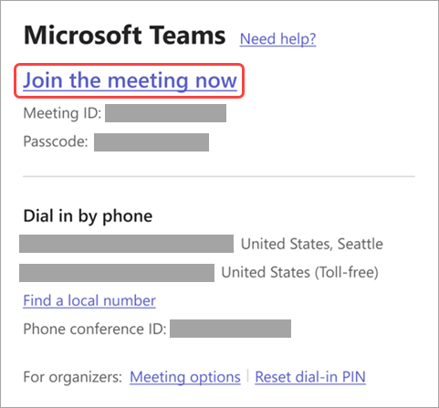

If you already have the Teams app, the meeting will open there automatically.

* If [you don’t have a Teams account](https://support.microsoft.com/en-us/office/join-a-meeting-without-an-account-in-microsoft-teams-c6efc38f-4e03-4e79-b28f-e65a4c039508) and the organizer has allowed it, you can enter your name to join the meeting.
* If you have a Teams account, select **Sign in**to join with access to the meeting chat and more. You'll then join the meeting right away or enter the lobby until an organizer admits you.

**Call in**

If you can't use the Teams app or Teams for web, join some meetings by phone number. Learn more here: [Join a Teams meeting by phone](https://support.microsoft.com/en-us/office/join-a-teams-meeting-by-phone-1e710768-bde6-4289-a1f9-17a20ff9b8ee).

If you find a phone number and conference ID in the meeting invite, dial the number to join.  
  
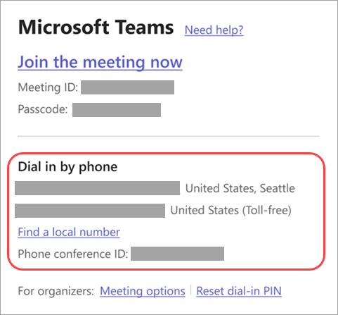

If you're the meeting organizer, you'll need to enter the dial-in PIN when you call in to a meeting.

Need help finding the dial-in PIN? Select **Reset dial-in PIN** on the meeting invite. Make sure you save the PIN somewhere; you can only view it once when you reset it. If you forget your dial-in PIN, reset it again.