
MAY 2026 |  | May 2  First Sunday in May is International Family Equality Day  May 5 is Red Dress National Day of Awareness for Missing and Murdered Indigenous Women, Girls, and 2SLGBTQ+ Peoples. | May 9  Visit from Author – Tamika  May 10 is Mother’s Day. | May 16  May 17 is International Day Against Homophobia, Biphobia. And Transphobia.  May 19 is Agender Pride Day | May 23  May 24 is Pansexual and Panromantic Day  May 25 is African Liberation Day.  Doors Open Weekend | May 30  Field Trip to Riverdale Farm (201 Winchester Street). Registration required.
Creative Arts  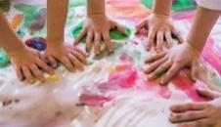 | Details | 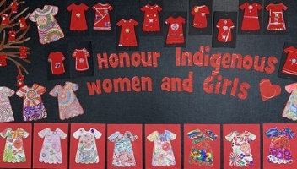  Decorating Red Dress | 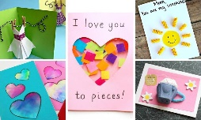  Creating a card for our chosen mothers. |   2SLGBTQ+ Collage making. |   Painting with panromantic colors | Field Trip to Riverdale Farm.  (201 Winchester St, Toronto, ON M4X 1B8)  Depart from The 519 at 10:15AM,  Meet in front of Riverdale Farm Gate by 10:45AM.  Registration required.
 | Materials | Cut out red dresses with crayons, markers and stickers | Paper, open ended materials, glue, crayons. | 2SLGBTQ pictures on a big white sheet of paper | Big sheet of paper; pink, yellow, and blue paint
Sensory/    Science/STEM | Details | 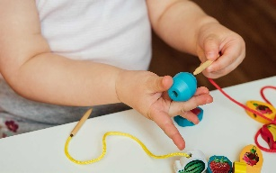  Can you sew? Practicing fine motor skills. | 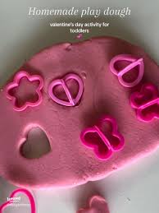 | 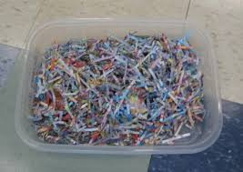  Finding words to stop the hatred. | 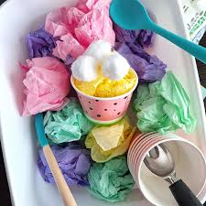  Crinkling paper
 | Materials | Blocks and strings. | Playdough + valentines cutters | Shredded paper | Paper tissue of pink, yellow, and blue
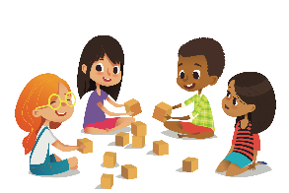  Cognitive | Details | 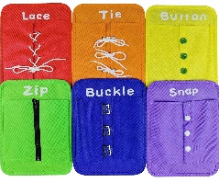  Self help board | Giving flowers to our chosen mothers or mother figures. | 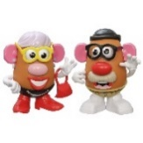  Exploring Gender Expression | 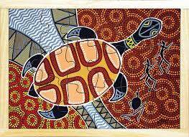
 | Materials | Self help board | Flower Links | Potato Head + accessories | Indigenous puzzles and indigenous animals
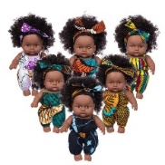  Dramatic | Details | 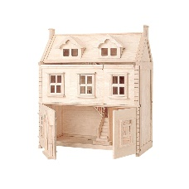  Who’s in your family? | 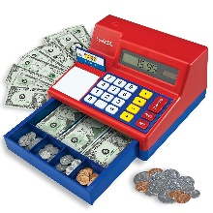  Buying groceries for Mother’s Day event | Marching for IDAHOT. | 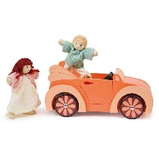  Liberation Day Parade
 | Materials | Doll house and doll house people | Cash register + pretend items to sell. | Dolls | Doll house people and vehicles.
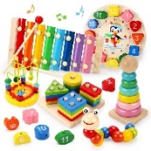  Infant | Details | 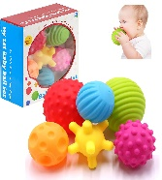  Playing catch with your grownup | Can you pretend to be a parent? | 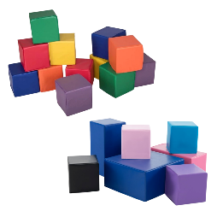  Building a safe space | 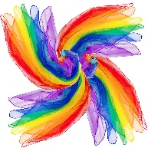  Scarves
 | Materials | Balls and books about family | Dolls | Foam blocks and cardboard blocks | Scarves and books
Language and Communication  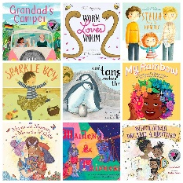 | Details | Book: “The Family Book” by Todd Parr | Author Tamika’s visit. | Book: “Neither” by Airlie Anderson | Book: “When Aidan Became a brother” by Kyle Lukoff
 | Materials | Instruments | Author Tamika’s visit. | N/A | Bubbles or instruments
 | Song Suggestions | I love you, you love me, skinamarink, the more we get together | Author Tamika’s visit. | The more we get together, zoom, zoom, I love you, you love me, skinamarink, number song, | The wheels on the bus, the more we get together,
Outdoor Play | Cognitive |  |  | Building with natural materials
Outdoor Play | Arts and Craft |  |  |  | Chalk and paper;  “leave a mark” poster making
Outdoor Play | Sensory/STEM |  | Buckets and shovel | Same as Cognitive | Spray Bottle
Outdoor Play | Physical | Trikes and bikes | Sled | Trikes and bikes | Basketball + wooden blocks

