
`
July 2026 |  | July 4 | July 11 | July 18 | July 25
Creative Arts  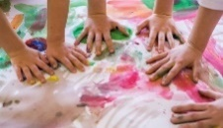 | Details | 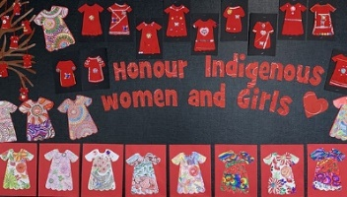  Decorating on Red | 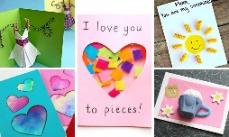  Creating a card for our chosen family. | 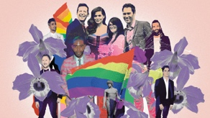  2SLGBTQ+ Collage Making: “Peoples and Hearts” |   Painting with Panromantic Colors
 | Materials | Cut out red construction paper with crayons, markers and stickers | Paper, open ended materials, glue, crayons | 2SLGBTQ pictures on a big white sheet of paper | Big sheet of paper; pink, yellow, and blue paint
Sensory/  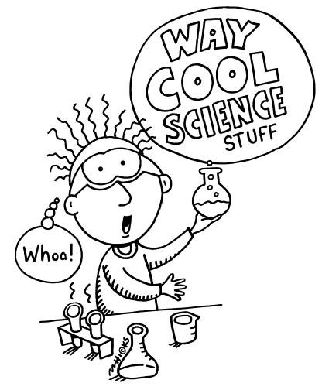  Science/STEM | Details | 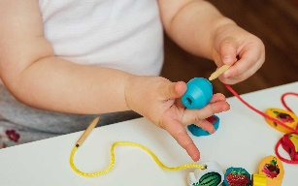  Can you sew? Practicing fine motor skills. | 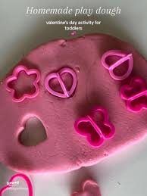 | 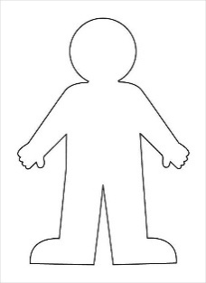  Creating A Friend | 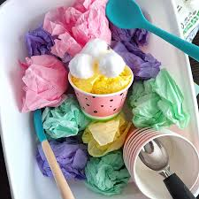  Crinkling paper
 | Materials | Blocks and strings. | Playdough + Cutters | Water Markers and Laminated People Shapes | Paper tissue of pink, yellow, and blue crumpled
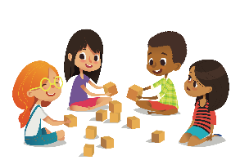  Cognitive | Details | 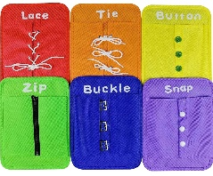  Self Help Boards | Sharing Flowers to our Friends | 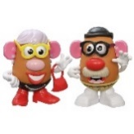  Exploring Gender Expression | 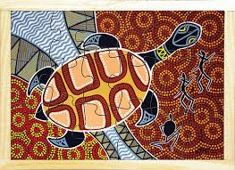
 | Materials | Self help board | Flower Links | Potato Head + Accessories | Indigenous Puzzles and Indigenous Animals
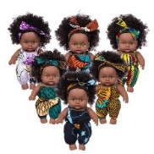  Dramatic | Details | 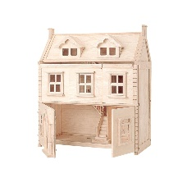  Who’s in your family? | 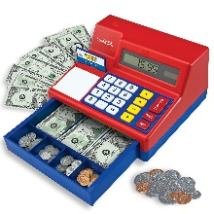  Buying Groceries for Summer Picnic | Marching in Summer | 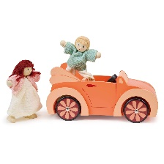  Liberation Day Parade
 | Materials | Doll house and Doll House Peoples | Cash Register + Pretend Items | Dolls | Doll House Peoples and Vehicles
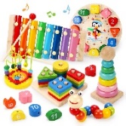  Infant | Details | 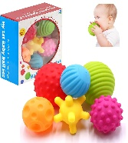  Playing catch with your grownup | Can you pretend to be a parent? | 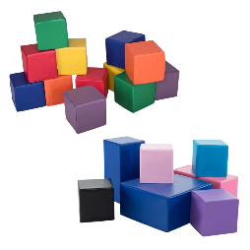  Building a Safe Space | 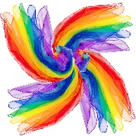  Scarves
 | Materials | Balls and books about family | Dolls | Foam blocks and cardboard blocks | Scarves and books
Language and Communication  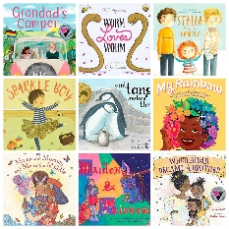 | Details | Book: “The Family Book” by Todd Parr | Book: “Julian is a Mermaid” by Jessica Love  Scarves  You Are My Sunshine; ABCs; Counting Song | Book: “Pride Colours” by Robi Stevenson | Book: “A Church for All” by Gayle E. Pitman
 | Materials | Instruments |  | Scarves | Bubbles
 | Song Suggestions | I Love You, You Love Me; Skinamarink; The More We Get Together |  | The More We Get Together; Zoom, Zoom, Zoom; Swimming, Swimming | The Wheels on the Bus; The More We Get Together; The Grand Marshall of Pride; Bouncy Mouse
Outdoor Play | Cognitive | Outdoor Blocks | Counting Trees in Splash Pad | Building with Natural Materials | Comparing Different Sizes Vehicles
Outdoor Play | Arts and Craft | Spray Painting with Water Colours | Chalk and paper;  “leave a mark” poster making | Painting with Water | Outdoor Canvases
Outdoor Play | Sensory/STEM | Splash Pad | Buckets and Shovel | Same as Cognitive | Spray Bottle
Outdoor Play | Physical | Trikes + Bikes | Wagons | Hulla Hoops | Basketball + Wooden Blocks

