May 2026
Tuesday | Wednesday | Thursday | Friday
1
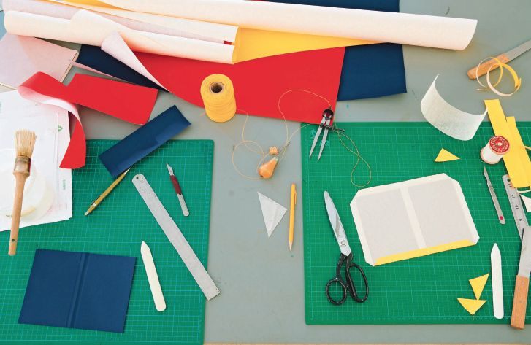
Cutting and Pasting Pictures

5  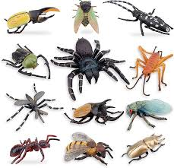  INSECTS! | 13  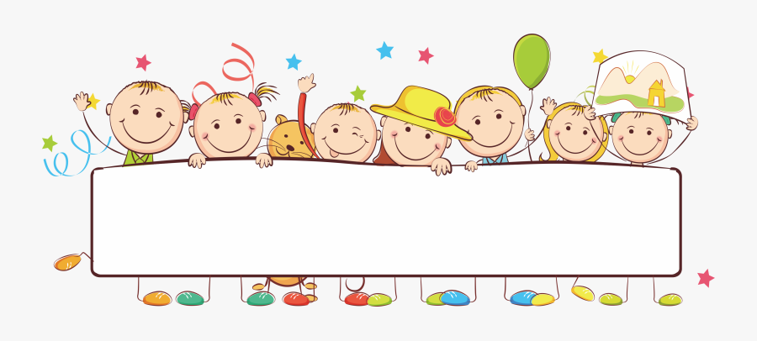  Creating Banner Art | 7    Spring Feast Potluck | 8  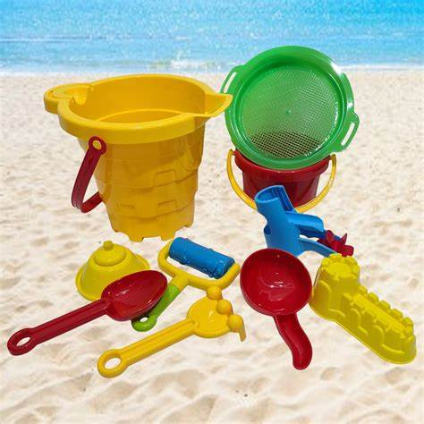  Sand Play!
12  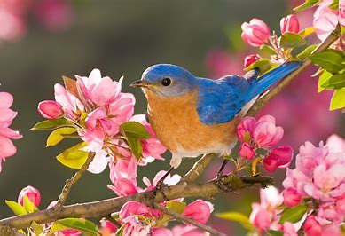  Spring bookmarks | 13  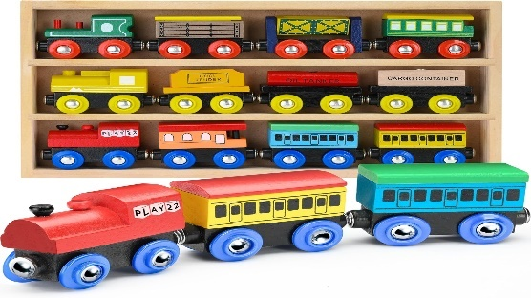  Toy trains | 14  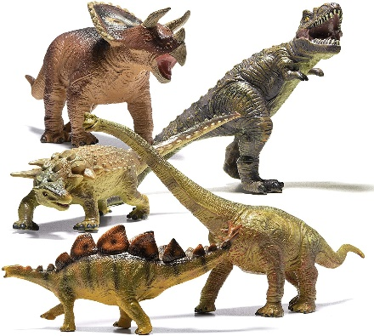  Dinosaurs! | 15  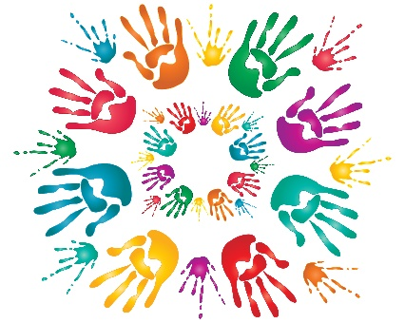  Creating art with Children’s Hand-prints
19    HIV Awareness  A Gender Pride Day! | 20  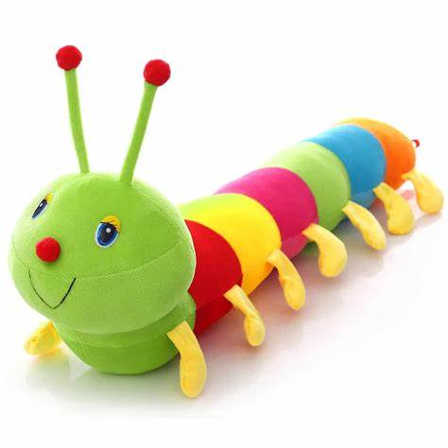  The very Hungry Caterpillar | 21  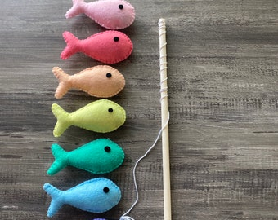  Fishing | 22  Designing Patterns with Chalk
26  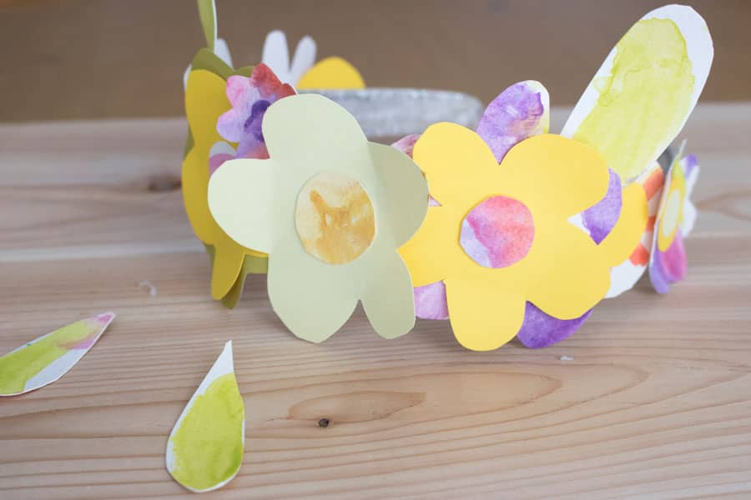  Creating Spring Crowns | 27  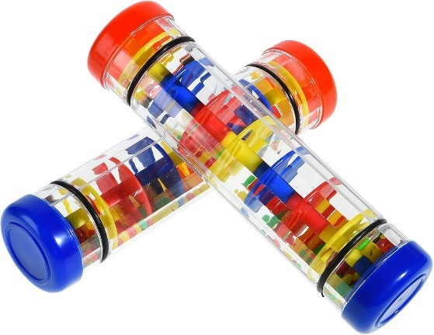  Drums and Rain Sticks | 28  EarlyON Closed:  ALL STAFF | 29    Family Portraits

