March 2025 – Women’s History Month
Tuesday | Wednesday | Thursday | Friday
3    STOP DISCRIMINATION DAY, March 1st | 4    Sorting Shapes, Not People | 5    HIV Awareness | 6  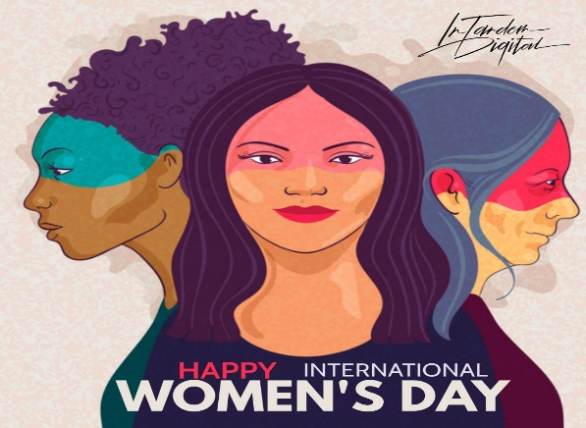  International Women’s Day
10  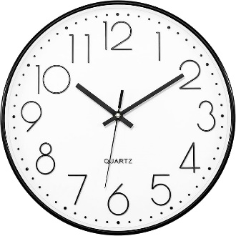  Day-light SAVINGS | 11    Potato- People | 12    Planting Seeds! | 13    Screen Time & Nature
17    St. Patrick’s Day | 18    Ready for Spring? | 19    Tissue Paper Flowers | 20  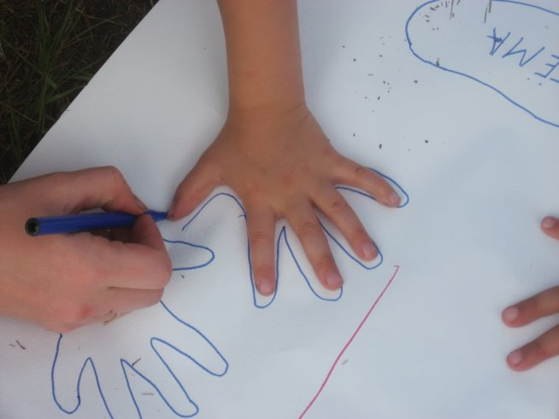  Tracing Hands
24    Anti- Slavery | 25    Decorating Red Ribbons | 26    Infant Beads | 27    Making Seeds Grow

